NVR8908T-Q(VGA)
H.265 1SATA Poe NVR T Series

Parameters：
Features：

 | Model | NVR8908T-Q(VGA)
System | processor | Hi3798M
 | system | Embedded Linux
Video | Video input | 4ch4K/4ch 5M/8ch4M/4ch3M/12ch1080P/  16ch960P
 | Playback | 1ch4K/2ch 5M/2ch4M/4ch3M/4ch1080P/  4ch960P
 | Decode | H.265/H.264
Audio | Compression | G.711a
 | Intercom | Unsupport
Management | Record mode | Manual>Alarm>Motiondetection>Timing
 | Inquire mode | Inquire by Time/Calendar/Event/Channel
 | Storage mode | HDD Storage, Network Storage
 | Backup | Network, USB, SATA
Interface | HDMI output | 1*HDMI (MAX:4K)
 | VGA output | 1*VGA (MAX:1080P)
 | Ethernet port | 1*RJ45 1*10/100Mbps Ethernet port,
 | POE ports | 8 standard POE ports
 | Audio I/O | 0/0
 | Alarm I/O | 0/0
 | USB Port | 2*USB2.0 ports
 | HDD | 1*SATA interface (Up to 8TB)
General | Temperature | 0 ℃ - + 55 ℃
 | Humidity | 10% -90% RH
 | Power supply | 48V/2.5A
 | Consumption | <10W（Without HDD）
 | Weight | Around 1.2KG
 | Dimension | 255(L)* 236mm(W)* 44mm(H)
- 4ch4K/4ch 5M/8ch4M/4ch3M/12ch1080P/
16ch960P video input;
- VGA、HDMI simultaneous video output;
- Mini 1U Case, 1SATA(Up to 8TB);
- H.265/H.264
- 1*10/100Mbps auto-sensing Ethernet port, RJ45 port；
- POE power over ethernet, 8 standard POE ports;
- Automatic networking support, a key to add equipment;
- Support the Onvif protocol;
- Support GB28181 (Optional);
- Cloud services, P2P, alarm information push to phone;
- Support remote access, support ARSP;
- "Support DHCP, FTP, DNS, DDNS, NTP, UPNP, EMAIL,
- 3G, WIFI, IP search, Alarm center, etc ;"
- Mobile phone remote monitoring (iOS, Android);
- Multi browser access (IE, Chrome, Firefox, Safari);
- Support for more than twenty languages;
- Perfect protection circuit, unique triple watchdog function;
- Support WEB, CMS, VMS, MYEYE Platform;
Model：
NVR8908T-Q(VGA)
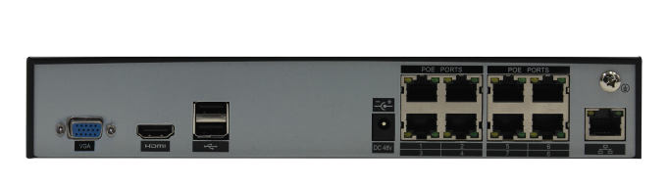
Interface：

